Certificate COMPLETION

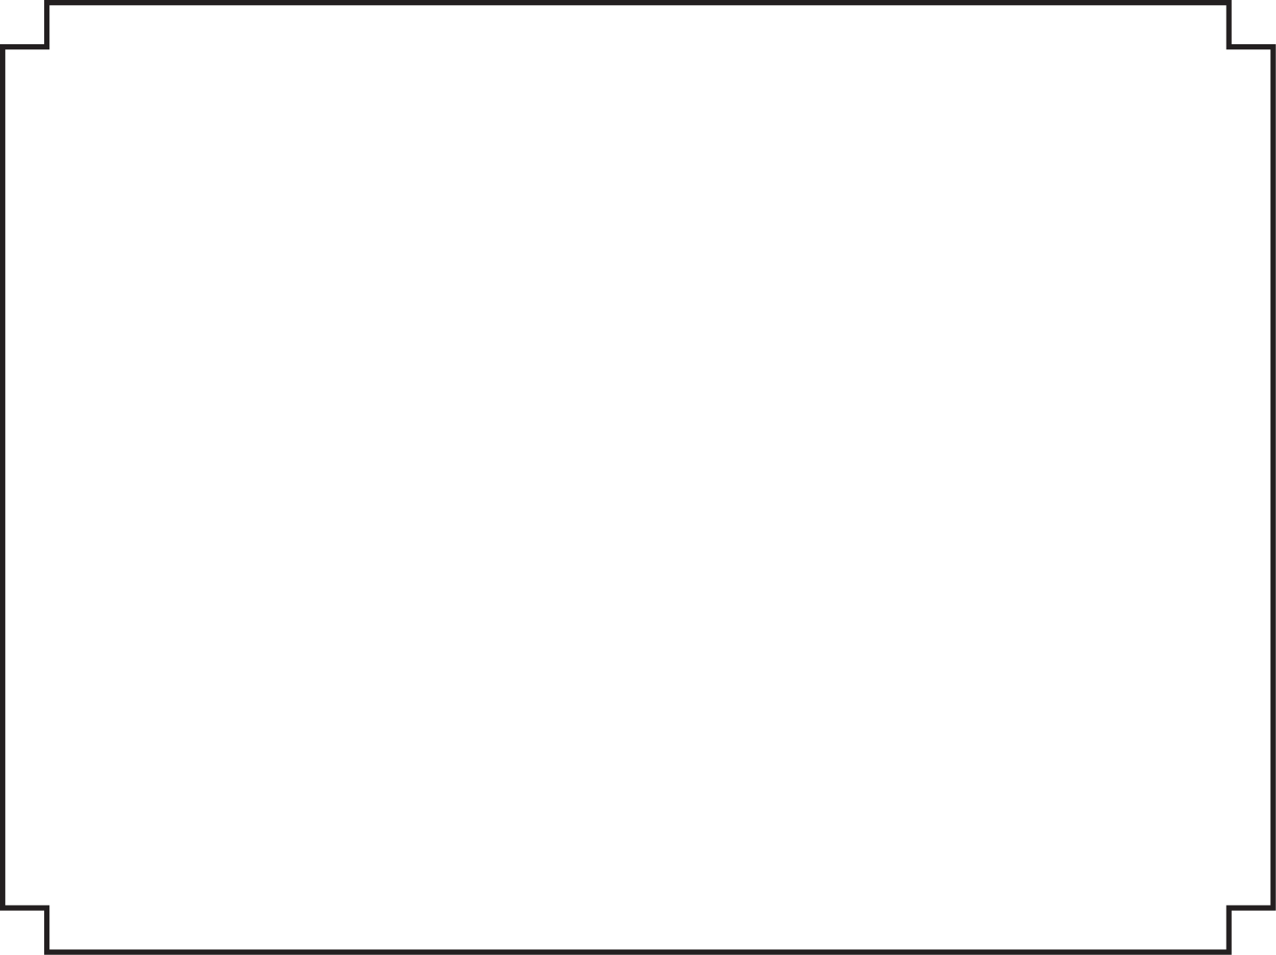

[Recipient Name]

Has successfully completed all required coursework in **REAL Entrepreneurship**

[Community College or org. here]

|  |  |  |  |  |  |  |
| --- | --- | --- | --- | --- | --- | --- |
| C:\Users\Russ\Desktop\NC-REAL-Logo small.png |  | |  |  | | --- | --- | | Presented By: | [Signatory name(s)] | | On This Day: | [Click to select a date] | |